SOLUTION OF MODULE 2
Question1: https://www.hackerrank.com/challenges/conditional-statements-in-c/problem?isFullScreen=false
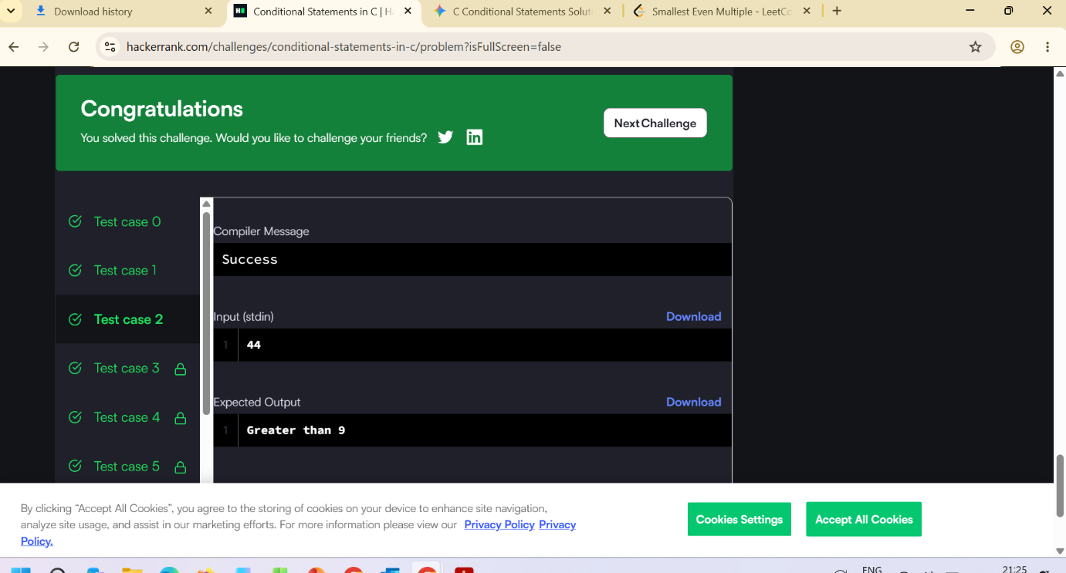
Question 2: https://leetcode.com/problems/smallest-even-multiple/submissions/2192591749/
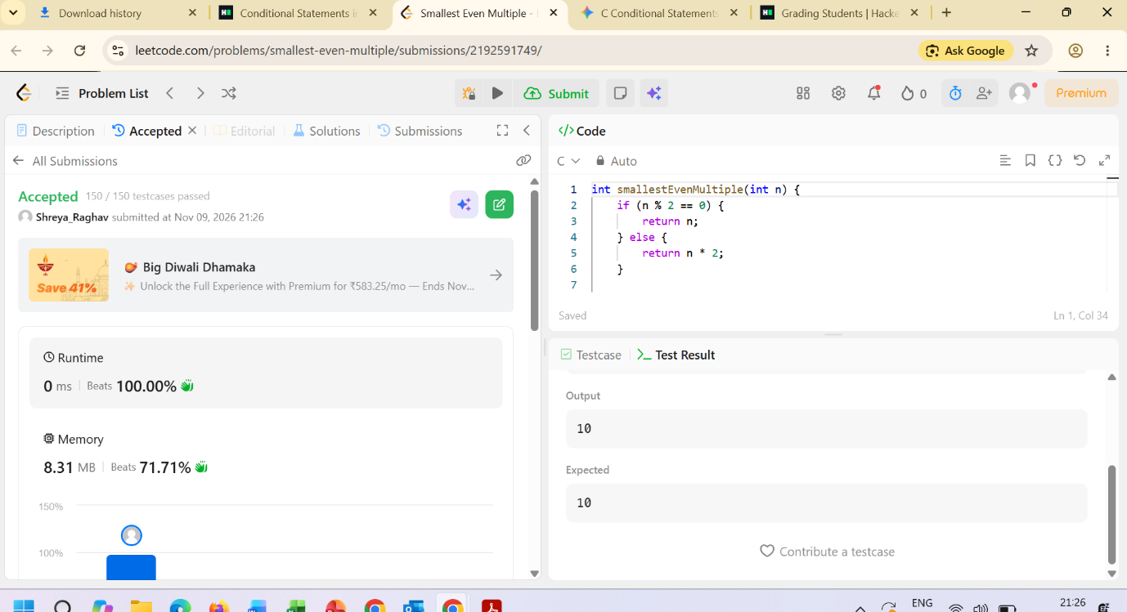
Question 4: https://www.hackerearth.com/practice/basic-programming/input-output/basics-of-input-output/practice-problems/algorithm/roy-and-profile-picture/
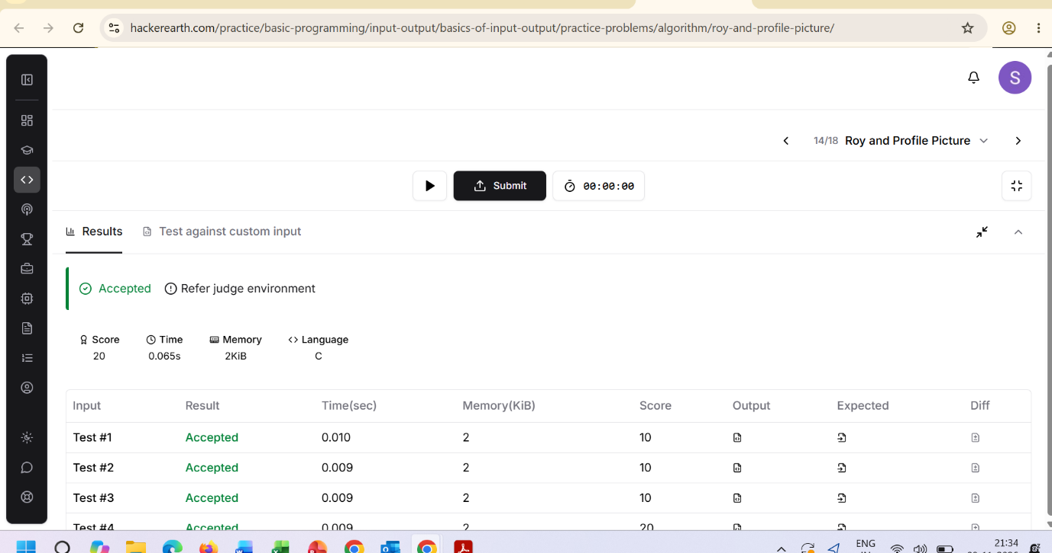

Question 5: https://www.hackerrank.com/challenges/fizzbuzz/problem

